**Exercise 1: Implementing the Singleton Pattern**

public class Logger {

private static Logger instance = null;

private Logger() {

System.out.println("Logger initialized");

}

public static Logger getInstance() {

if (instance == null) {

instance = new Logger();

}

return instance;

}

public void log(String message) {

System.out.println("LOG: " + message);

}  
public class LoggerTest {

public static void main(String[] args) {

Logger loggerA = Logger.getInstance();

loggerA.log("Starting up");

Logger loggerB = Logger.getInstance();

loggerB.log("Running module A");

if (loggerA == loggerB) {

System.out.println("Same Logger instance used");

} else {

System.out.println("Different Logger instances found");

}

}

}

}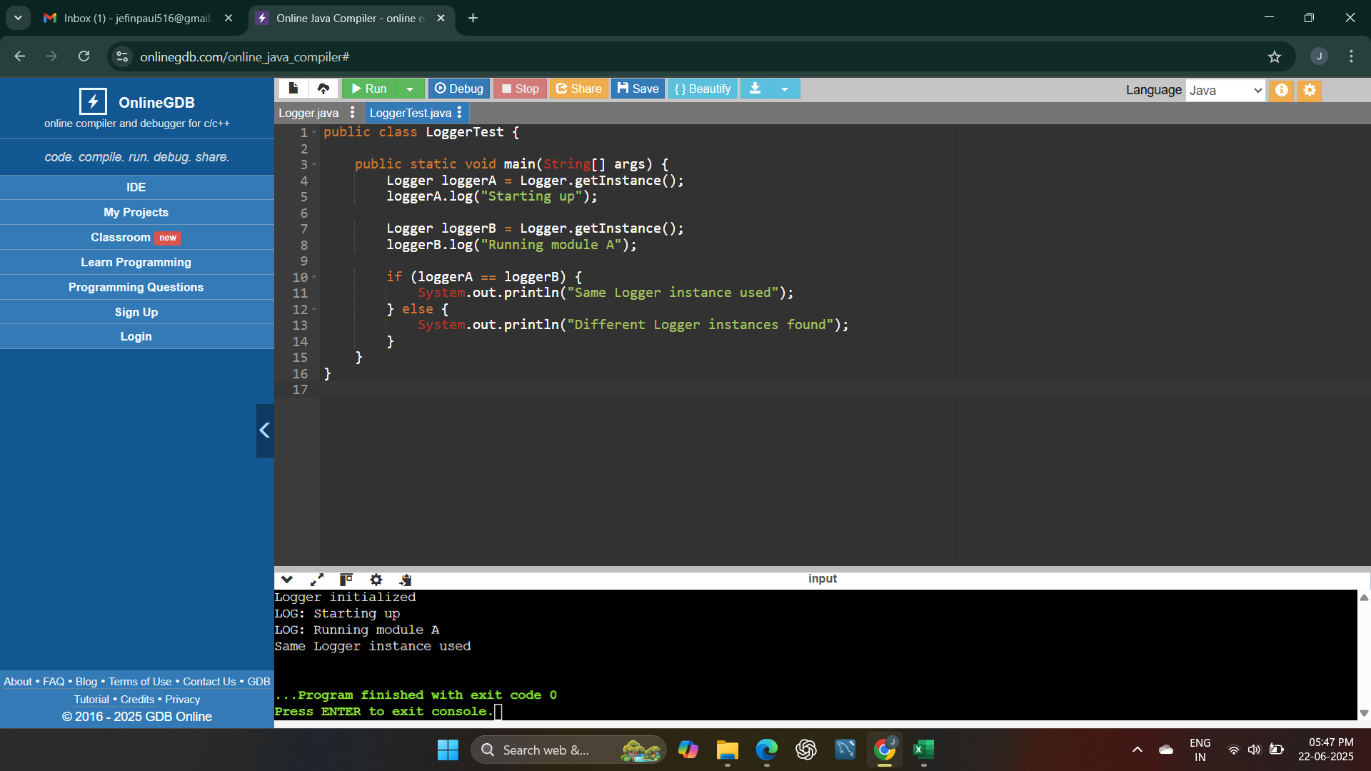

**Exercise 2: Implementing the Factory Method Pattern**

public interface Document {

void open();

}

public class WordDocument implements Document {

public void open() {

System.out.println("Opening Word Document");

}

}

public class PdfDocument implements Document {

public void open() {

System.out.println("Opening PDF Document");

}

}

public class ExcelDocument implements Document {

public void open() {

System.out.println("Opening Excel Document");

}

}

public abstract class DocumentFactory {

public abstract Document createDocument();

}  
public class WordFactory extends DocumentFactory {

public Document createDocument() {

return new WordDocument();

}

}

public class PdfFactory extends DocumentFactory {

public Document createDocument() {

return new PdfDocument();

}

}  
public class ExcelFactory extends DocumentFactory {

public Document createDocument() {

return new ExcelDocument();

}

}  
public class DocumentTest {

public static void main(String[] args) {

DocumentFactory wordFactory = new WordFactory();

Document word = wordFactory.createDocument();

word.open();

DocumentFactory pdfFactory = new PdfFactory();

Document pdf = pdfFactory.createDocument();

pdf.open();

DocumentFactory excelFactory = new ExcelFactory();

Document excel = excelFactory.createDocument();

excel.open();

}

}

